**Naïve Bayes : [Classification Technique]**

**#Importing Packages**

import pandas as pd

from sklearn import preprocessing

from sklearn.model_selection import train_test_split

from sklearn.naive_bayes import GaussianNB

from sklearn.metrics import accuracy_score

from sklearn.metrics import confusion_matrix

from sklearn.naive_bayes import *

**#Loading dataset**

dataset=pd.read_csv("train.csv")

dataset.columns

Out[10]:

Index(['PassengerId', 'Survived', 'Pclass', 'Name', 'Sex', 'Age', 'SibSp',

'Parch', 'Ticket', 'Fare', 'Cabin', 'Embarked'],

dtype='object')

**#Removing unwanted columns**

dataset=dataset.drop(['PassengerId','Name','Ticket','Cabin'],axis=1)

**#Converting text into numerical**

le=preprocessing.LabelEncoder()

dataset['Sex'] = le.fit_transform(dataset['Sex'])

dataset['Embarked'] = le.fit_transform(dataset['Embarked'])

dataset.head(5)

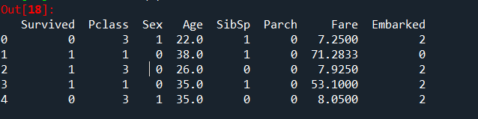

**#Implementing Naïve Bayes Theorum**

def Naive_bayesT(X,y):

X_train,X_test,y_train,y_test=train_test_split(X,y,test_size=0.3,random_state=0)

clf=BernoulliNB()

y_pred=clf.fit(X_train,y_train).predict(X_test)

acc_score=accuracy_score(y_test,y_pred,normalize=True)

conf_matrix=confusion_matrix(y_test,y_pred)

return acc_score,conf_matrix

dependent_variable=['Pclass','SibSp','Sex', 'Parch','Embarked']

for i in dependent_variable:

y=dataset[i]

X=dataset.drop(i,axis=1)

acc_score,conf_matrix=Naive_bayesT(X,y)

print("Accuracy Score for",i,"vs Remaining=",acc_score*100,"%\n")

print("Confusion Matrix:")

print(conf_matrix,"\n\n")

**#Result of Accuracy score and confusion matrix**

